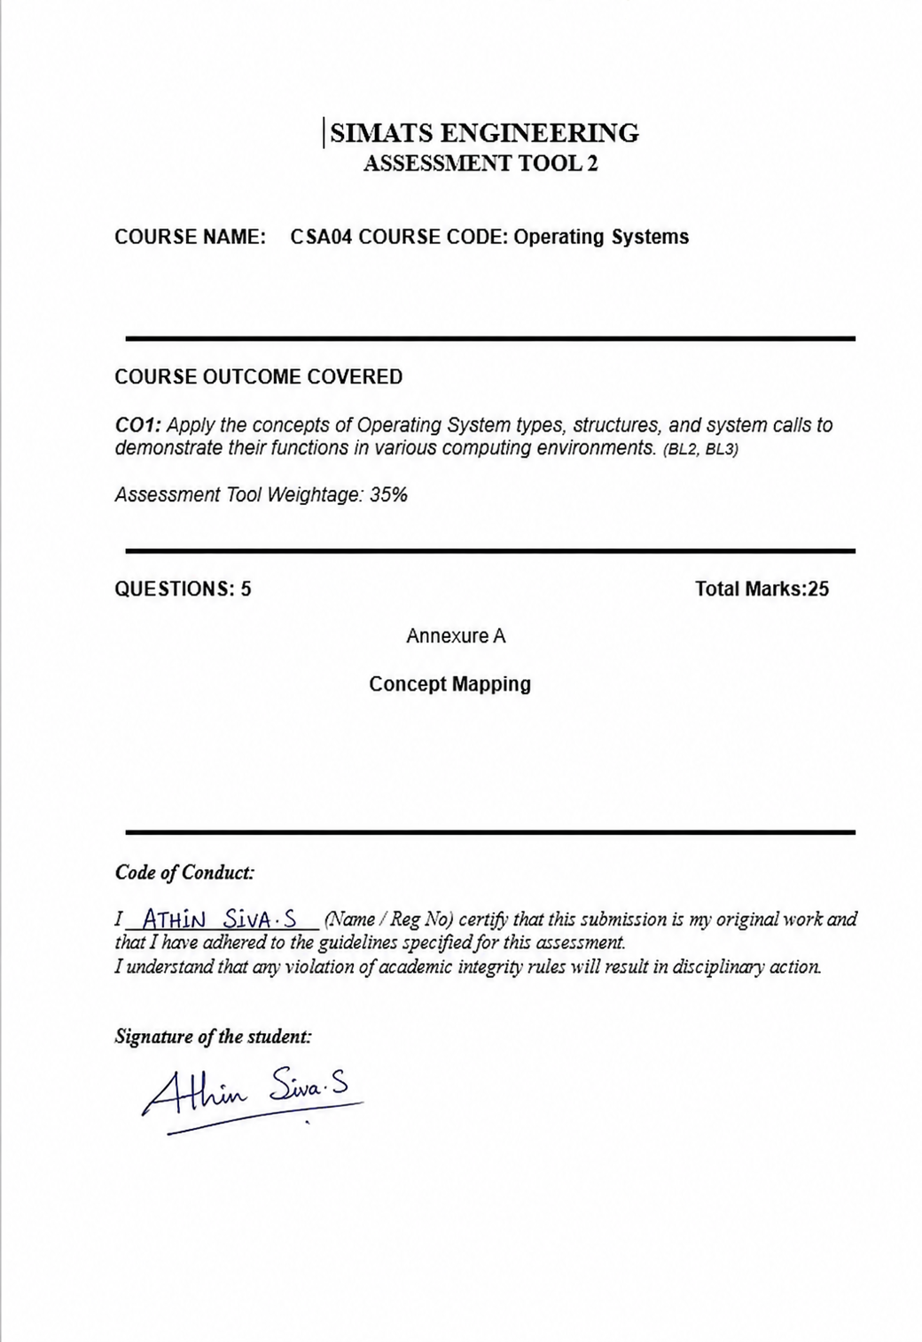

GPS LOGISTICS TRACKING
OS CONCEPT MAP • Real-Time • Secure • Reliable
OPERATING SYSTEM
Central controller of the logistics tracking system
Manages resources, users, processes, data and communication
↓ SUITABLE OS TYPE ↓
REAL-TIME • MULTIUSER • NETWORK / DISTRIBUTED OS
Suitable for continuous fleet-wide location updates, low-latency processing,
high availability, security and efficient resource sharing across vehicles and servers.
↓ OS SERVICES WORK TOGETHER ↓
👥 USER MANAGEMENT  Authentication • permissions  Dispatcher/driver accounts • roles | ⚙ PROCESS MANAGEMENT  Scheduling • multitasking  Tracking/geofencing tasks • sync | 🧠 MEMORY MANAGEMENT  Allocation • virtual memory  Buffering • location data caching
📁 FILE MANAGEMENT  Create • read • write  Trip logs • access control | 🔌 DEVICE / I-O  Drivers • input/output  GPS receivers, sensors & modems | 🌐 COMMUNICATION  Sockets • IPC • networking  Vehicle/server data exchange
↕ INTERACTION AMONG MODULES ↕
GPS SIGNAL/  LOCATION UPDATE | SYSTEM CALL /  KERNEL | PROCESS +  MEMORY | I/O +  NETWORK DEVICE | FLEET MAP  UPDATE
↔ RELEVANT SYSTEM CALLS ↔
PROCESS  fork() • exec() • wait() | MEMORY  mmap() • brk() • shmget() | FILES  open() • read() • write() | NETWORK  socket() • connect() • send()

CORE GOAL → Real-time accuracy + reliability + security under heavy tracking workload

